**Task 1: Create a Web App and SQL Database**

1. **Create an SQL Database in Azure:**
   1. **Log in to the Azure Portal:** Go to [Azure Portal](https://portal.azure.com).
   2. **Create a SQL Database:**
      1. Click on "Create a resource."
      2. Search for "SQL Database" and select it.
      3. Click on "Create."
      4. Fill in the required fields (subscription, resource group, database name, etc.).
      5. Select or create a new SQL server.
      6. Choose the pricing tier and click "Review + create," then "Create."

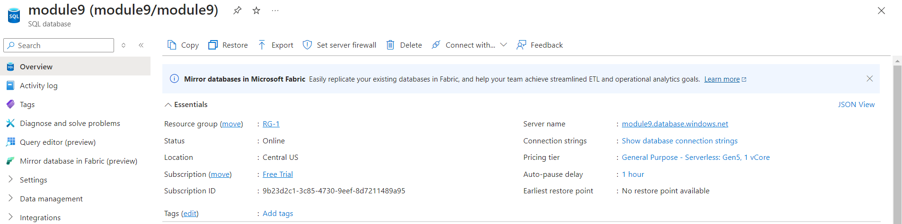

1. **Create a Web App:**
   1. **Create a Web App in Azure:**
      1. Click on "Create a resource."
      2. Search for "Web App" and select it.
      3. Click on "Create."
      4. Fill in the required fields (subscription, resource group, name, runtime stack, etc.).
      5. Click "Review + create," then "Create."

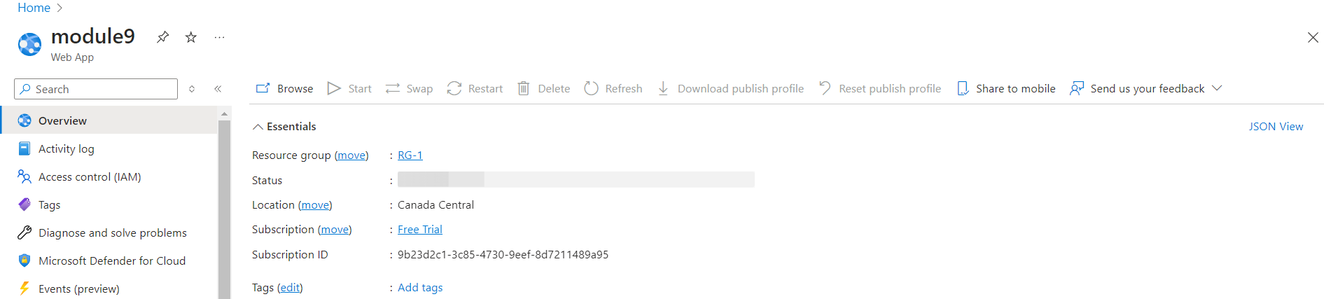

1. **Connect the Web App to the SQL Database:**
   1. **Set Up the Database Server Firewall**
      1. Go to your SQL server in the Azure portal.
      2. Click **Set server firewall**.
      3. Add the IP addresses that need access to the database, including your development machine and the Azure Web App.
      4. Click **Save**
   2. **Get the Connection String**
2. In the Azure portal, go to your SQL database resource.
3. In the left menu, under Settings, click Connection strings.
4. Copy the connection string (e.g., for ADO.NET or SQLAlchemy for Python).
   1. **Open Your Web App**:

* Navigate to **App Services** in the left-hand menu.
* Select your web app from the list.
  1. **Go to Configuration**:
* In the left-hand menu for your web app, select **Configuration** under the **Settings** section.
* **Add a New Connection String**:
* Under the **Connection Strings** tab, click **New connection string**.
* Fill out the fields:
  + **Name**: Use a descriptive name (**module9connection**).
  + **Value**: Use your connection string in this format:

**sqlsrv:server = tcp:module9.database.windows.net,1433; Database = module9; UID = sql; PWD = {your_password_here}; Encrypt = true; TrustServerCertificate = false;**

* + **Type**: Select **SQLAzure**.
* Click **Save** to apply the changes.

**Task 2: Launch Application Insights for Your Web App**

1. **Create an Application Insights Resource:**
   * In the Azure Portal, click on "Create a resource."
   * Search for "Application Insights" and select it.
   * Click "Create."
   * Fill in the required details (name, application type, resource group).
   * Click "Review + create," then "Create."

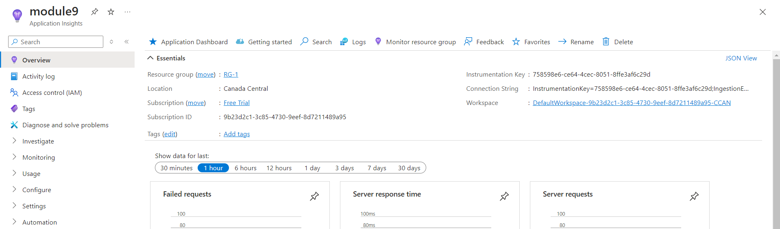

1. **Enable Application Insights in Your Web App:**
   * Go to your Web App in the Azure Portal.
   * In the left sidebar, click on "Application Insights."
   * Click on "Turn on Application Insights."
   * Choose the Application Insights resource you created and save the settings.

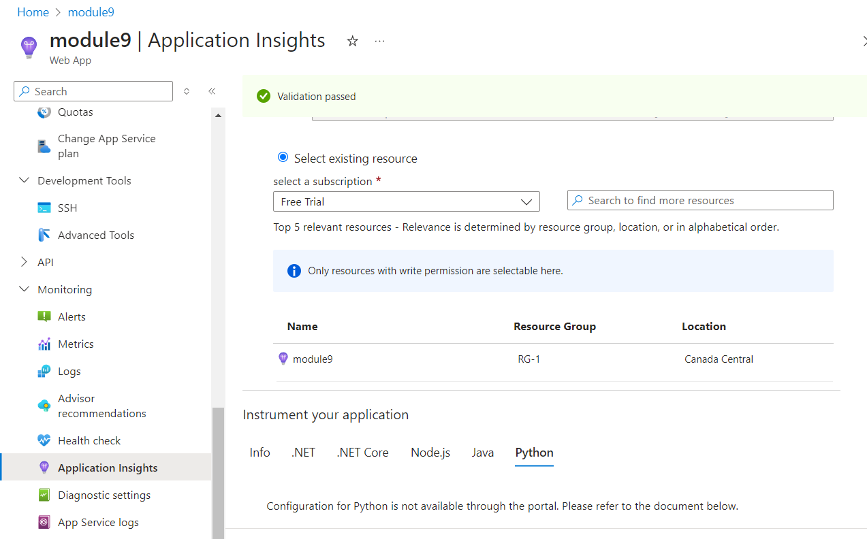

**Task 3: Monitor the SQL Database Using Azure Metrics and Log Analytics**

**Step 1: Enable Monitoring for Azure SQL Database**

1. **Select Your SQL Database**:
   * In the left-hand menu, select **SQL databases**.
   * Click on the specific database (module9).
2. **Enable Diagnostic Settings**:
   * On the database page, click on **Diagnostic settings** under the **Monitoring** section.
   * Click **Add diagnostic setting**.
   * Give the diagnostic setting a name (SQLMonitoring).
   * Select **Send to Log Analytics workspace**.
   * Choose or create a **Log Analytics workspace**.
   * Select the following logs and metrics for monitoring:
     + **SQLInsights** for SQL queries, failed connections, successful connections.
     + **DataSpaceUsed** to track the amount of data used.
   * Click **Save**.

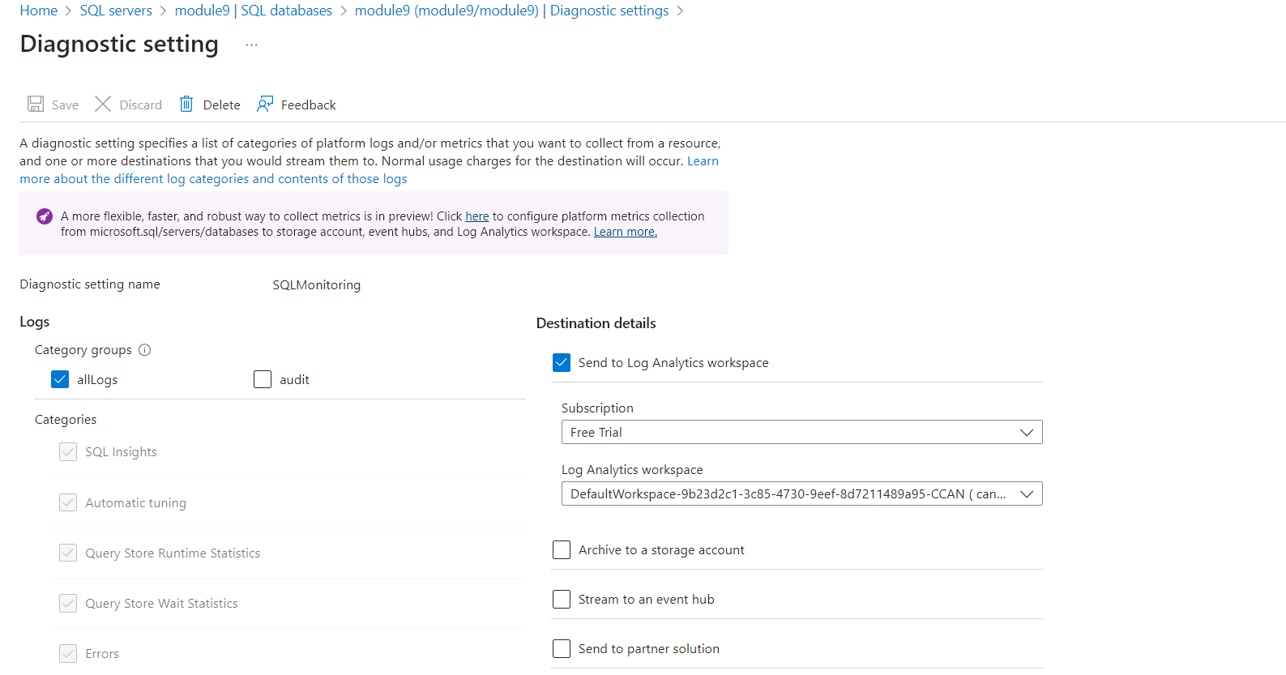

**Step 2: View Metrics in Azure Monitor**

1. **Go to Azure Monitor**:
   * In the left-hand menu of the Azure portal, select **Monitor**.
2. **View SQL Database Metrics**:
   * In **Monitor**, select **Metrics** from the left-side menu.
   * Select **SQL Database** as the resource type.
   * Choose your database from the list of available resources.
3. **Select Metrics**:
   * Select the **Metrics** you want to monitor:
     + For "Successful Connections": Choose **Successful connections** under the available metrics.
     + For "Data Space Used": Choose **Data space used**.
4. **Configure Chart for a Specific Time Period**:
   * At the top of the Metrics pane, select the **time range** you want to visualize (Last 24 hours).

